General tips for the Task below.
Task Title
AWS- RDS (Relational Database Service)
Objective
Worked on pre-requisite, as I watched the AWS-RDS posted in DevOps group in slack and task to work on below.
Prerequisites
List all requirements before starting:
- AWS-RDS
Issues Faced: Briefly mention issues and how you fixed them. Posted below in the last.
Conclusion
Conclusion has been provided for every task at the end.

AWS- RDS
What is RDS?
Ans- RDS is a web service that makes it easy to set-up and maintain our Database in AWS Cloud.
- Cost-efficient
- RDS can be re-sized at any point of time.
- We can resize memory, CPU or storage
- We can use regular DB’s like Maria DB, My SQL, Oracle, Microsoft SQL etc.
- Great advantage is we can use multi-AZ option to replicate the entire DB as a standby.
- For every replica, we will get an endpoint.

Types of RDS:
- Relational Database Service
- Non-Relational Database Service

Relational Database Service:
- RDS stores information in tables.
- These tables shared information between them, forming a relationship to form tables.
Ex: My SQL (Structured Query Language), Oracle, Postgres SQL etc..

Non-Relational Database Service:
- This is a kind of DB there is no format like tables, fields or columns.
- It can be built in any format.
- Sometimes called NoSQL.
Ex: Mongo DB, Big Table, Raven DB, Cassandra and Couch DB.

2 ways to work on Database service in AWS
- Ec2
- RDS
EC2/RDS:
- There are pros and cons installing or using ec2/RDS for Databases.
PROS:
- Access to the DB instance O.S
- Client/Vendor request
- D.B version details ec2 provides.
CONS:
- Admin Overhead
- Backup and Disaster Recovery is on us.
- Ec2 is running on single availability zone (recovery is not possible)
- New features on aws is not available in ec2.
- Performance issues compared to aws RDS.

Why AWS RDS?
- High Availability with Multi-AZ’s
  - It will automatically create a snapshot and provide a standby/replica
  - Failover will be taken care by AWS
- Automated Backups and Restore
  - This feature is a major advantage where it automatically takes snapshot and restores the DB.
  - Whereas in ec2, it’s a manual process, we need to take a snapshot and work with AWS team for the lost data.

- Read Replicas
  - This is a great feature in RDS where, instead of providing a onload on the primary instance, this feature automatically redirects everyone to another instance to improve the primary instance performance.

- Compatibility:
  - Supports Maria DB, MySQL, Oracle, Microsoft SQL etc.

Task on RDS

- Create MariaDB DB on EC2.
Objective:
To enable and deploy Maria DB package on AWS ec2 instance with secure, scalable and cost-effective data storage.
Pre-requisites:
- EC2
- Maria DB package
Step by step Implementation:
Step 1: Navigate to ec2 and launch a instance with all default configurations.
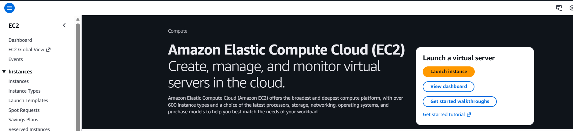

Step 2: we shall connect using aws cli
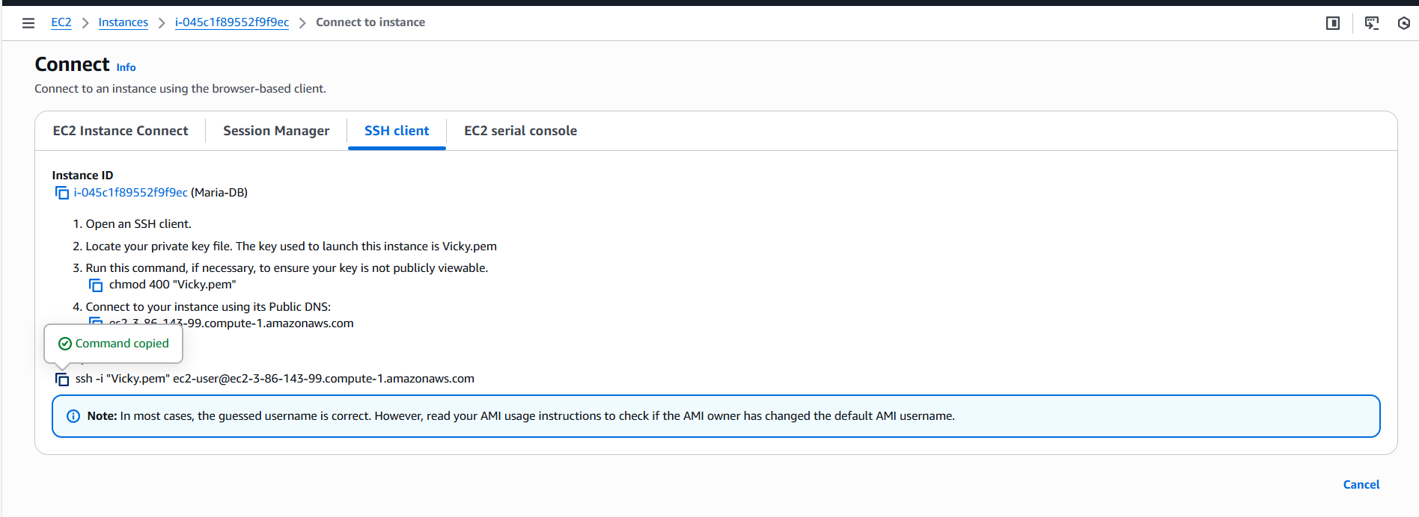

Step 3: We shall update the packages.
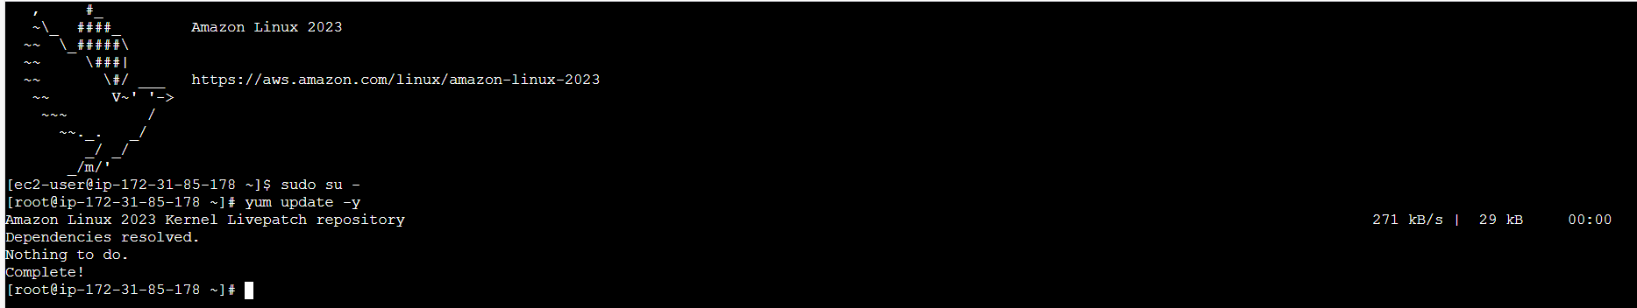

Step 4: Its time to install Maria DB package on the cli.
- Command to install Maria DB- yum -y install mariadb105-server.
- 105 is version 10.5 of Maria db and Amazon Linux provides support to that version as of now.
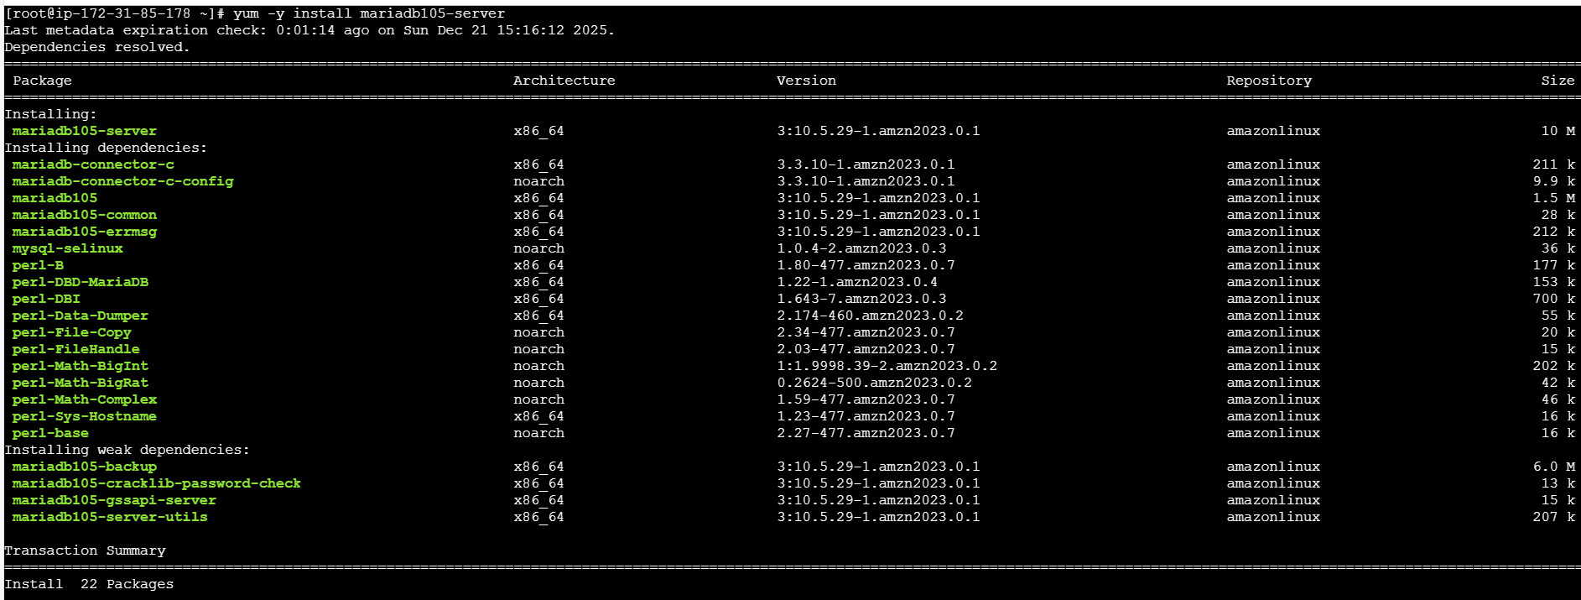
- Package is installed successfully.
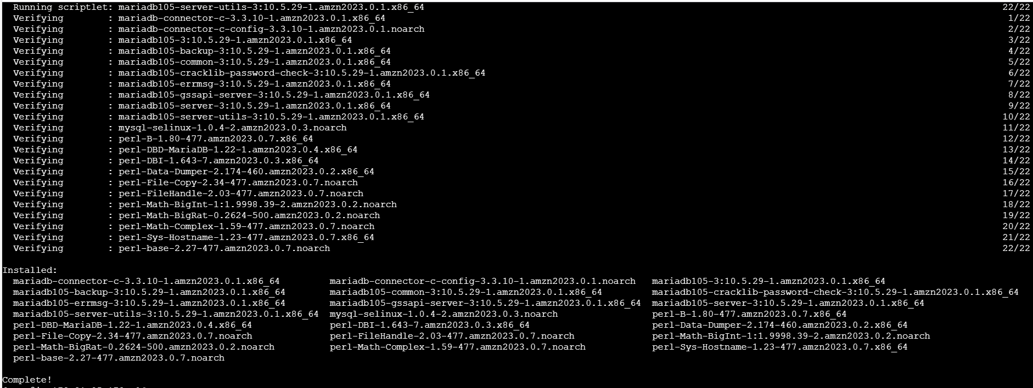

Step 5: Successfully, the package is installed. Now, lets create some credentials including DB name, DB password, DB Root password and DB user.
Credentials updated
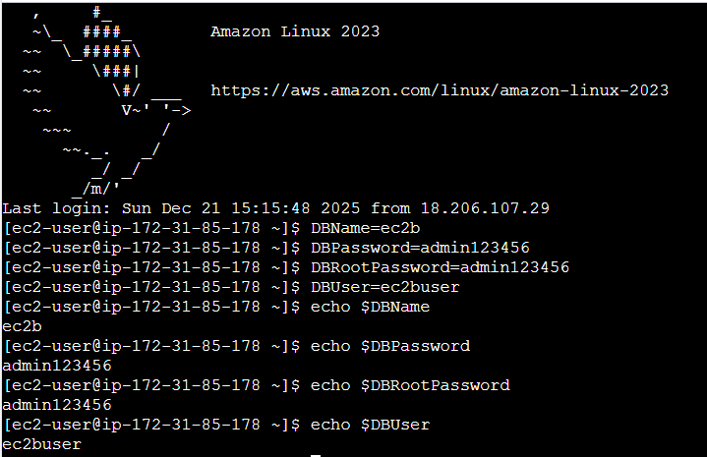

Step 6: Once credentials updated in cli for Maria db, we need to provide access and privileges to user.
There are few commands that needs to be run including:
- Creating Database- echo "CREATE DATABASE ${DBName};" >> /tmp/db.setup
- Creating user- echo "CREATE USER '${DBUser}' IDENTIFIED BY '${DBPassword}';" >> /tmp/db.setup
- Grant all Privileges- echo "GRANT ALL PRIVILEGES ON *.* TO '${DBUser}'@'%';" >> /tmp/db.setup
- Flush Privileges- echo "FLUSH PRIVILEGES;" >> /tmp/db.setup
Once provided, change Directory to /tmp and list all the files.
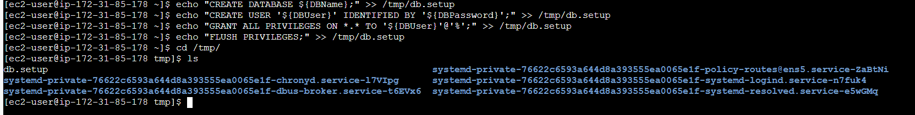

Step 7: We can verify the privileges by using command- cat db.setup
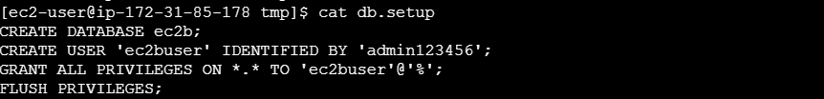

Step 8: Finally, we shall start and enable the service
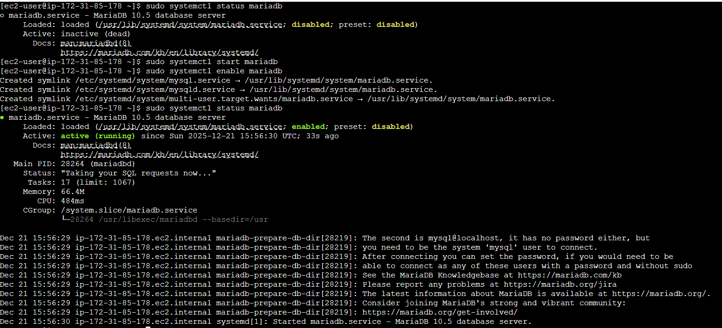

Step 9: Let’s secure the installation using command- sudo mysql_secure_installation
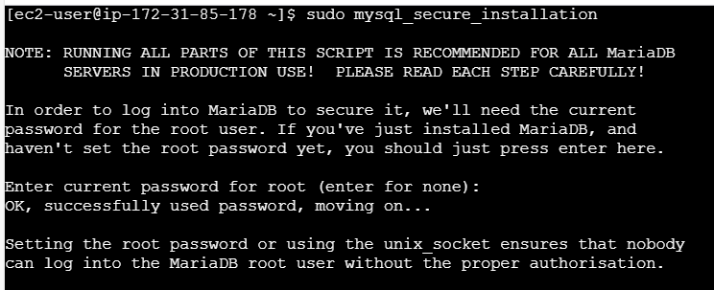

Issues faced:
While connecting to instance, SSH wasn’t added to SG, so couldn’t get connected to cli.
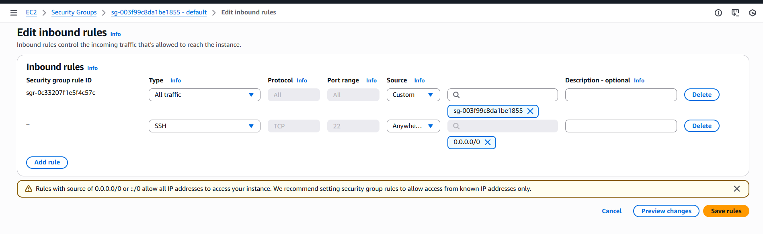
- We need to install Maria db version on the respective Linux image.

Conclusion:
Maria DB is running successfully.

- Insert some dummy data.
Objective:
Using cli, providing some dummy data to trigger some data present in Maria db server.
Pre-requisites:
- Ec2
- Maria db
- SQL to create tables and rows
Step by step Implementation:
Step 1: Using command- mysql -u root -p login to maria db.
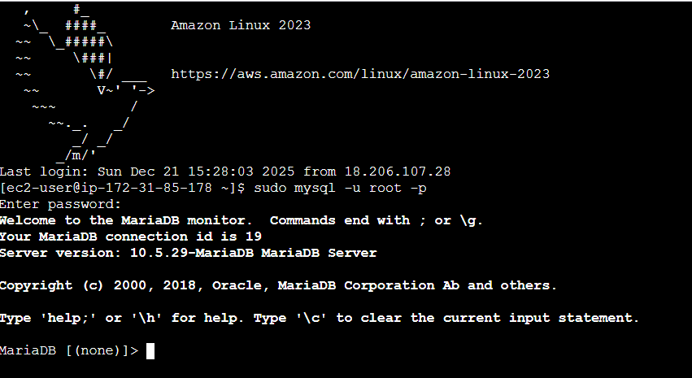
Step 2: Now, let’s check if we have existing Databases- SHOW DATABASES;
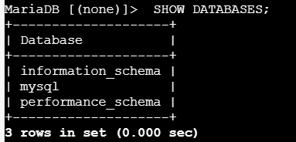
- After verifying, create- CREATE DATABASE <SCHOOL>;
- Once again verify the Databases- SHOW DATABASES;
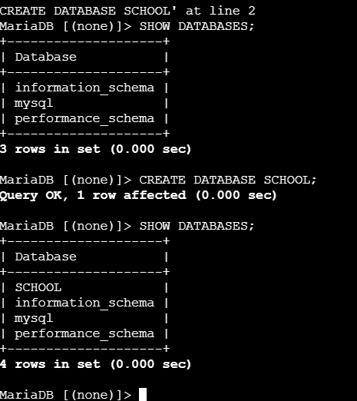
Step 3: Now, we changed our Database to School using command- USE SCHOOL;
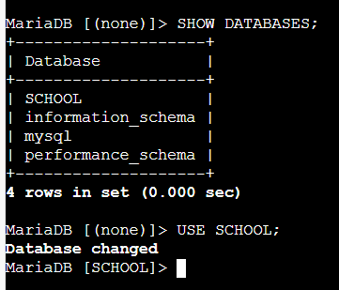

Step 4: Let’s create a table under our Database School- CREATE TABLE <Students> (id INT, name VARCHAR(45));
- Using command to verify if the Table is created- SHOW TABLES
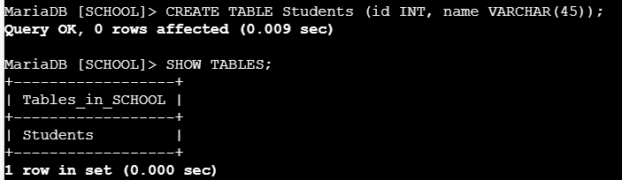

Step 5: Once Table created as Students, now, we need to add the Students to the list. Used command- INSERT INTO <STUDENTS> (id, name)
- Then use command- SELECT * FROM <Students> to list the added Students in the list.
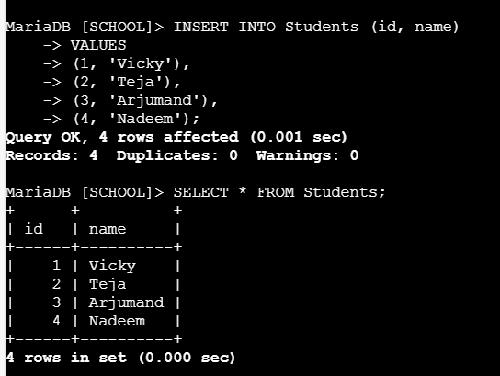

Issues faced:
Due to the case sensitive and (symbol;) it was a turnaround of re-work.
Conclusion:
Maria DB is working well, we created Database, tables and updated them accordingly. This shows Relational database is working well on ec2 server.

- Take the backup of dummy data on EC2.
Objective:
The objective of this task is to take the backup of previously created dummy tables under maria db server.
Pre-requisites:
- Ec2
- Maria DB
- MySQL dump
Step by step Implementation:
Step 1: First, we need to exit from the previous work using command- ctrl+z
- Login back using command- sudo mysql -u root -p
- Change the directory to root.

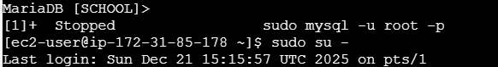

Step 2: Now, let’s take the backup of our Database created earlier using command- mysqldump -u root -p <SCHOOL> >SCHOOLbackup.sql
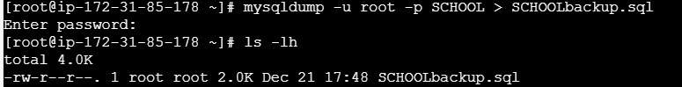

Step 3: Now, lets verify if the backup is successful. Use command- cat SCHOOLbackup.sql
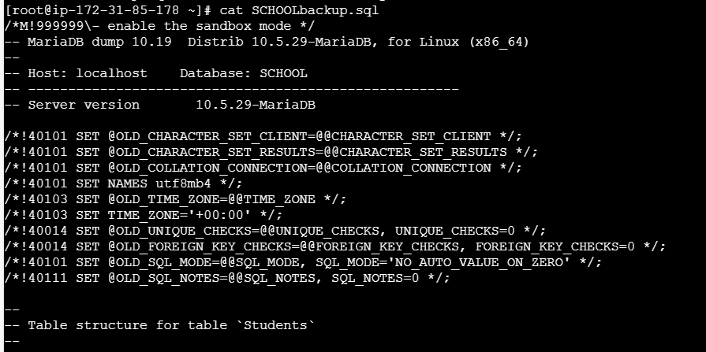
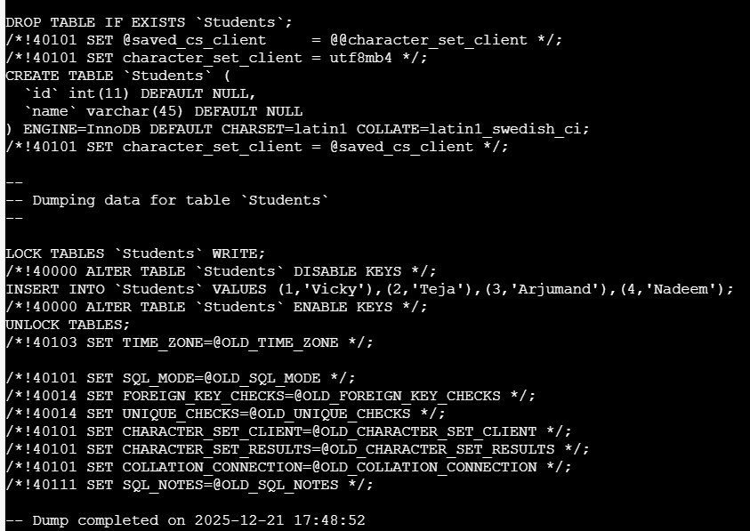

Issues faced:
We need to exit from the maria db and login back to take the backup.
Conclusion:
Successfully, we were able to take the dump using logical backup- mysqldump is created.

- Launch MariaDB RDS instance.
Objective:

We shall launch a Maria DB RDS instance which provides a secure and scalable DB services in AWS.

Pre-requisites:
- RDS
- Ec2
Step by step Implementation:
Step 1: Navigate to Aurora and RDS and create a new database for our requirement.
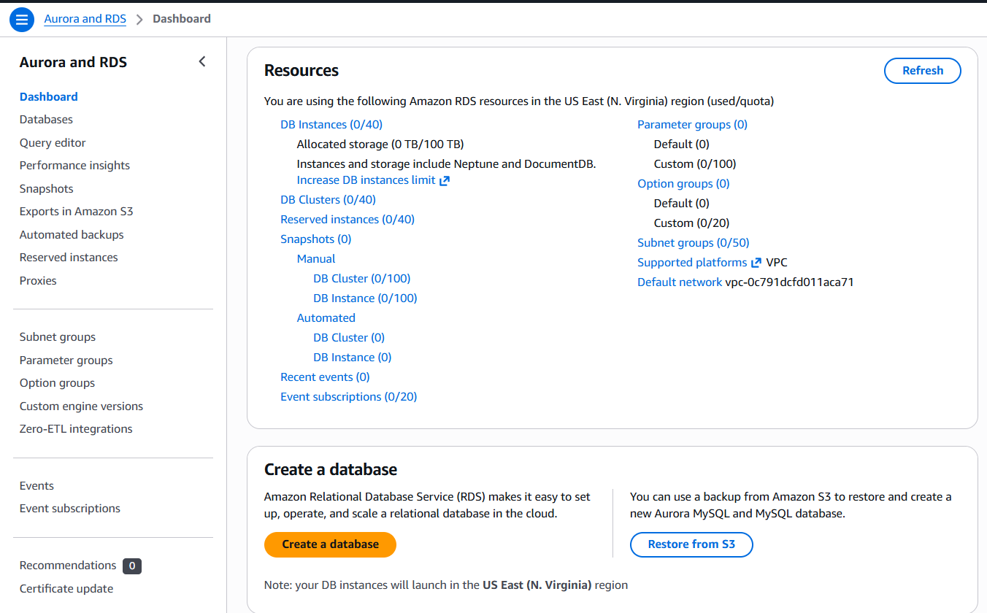

- Select MariaDB from the list.
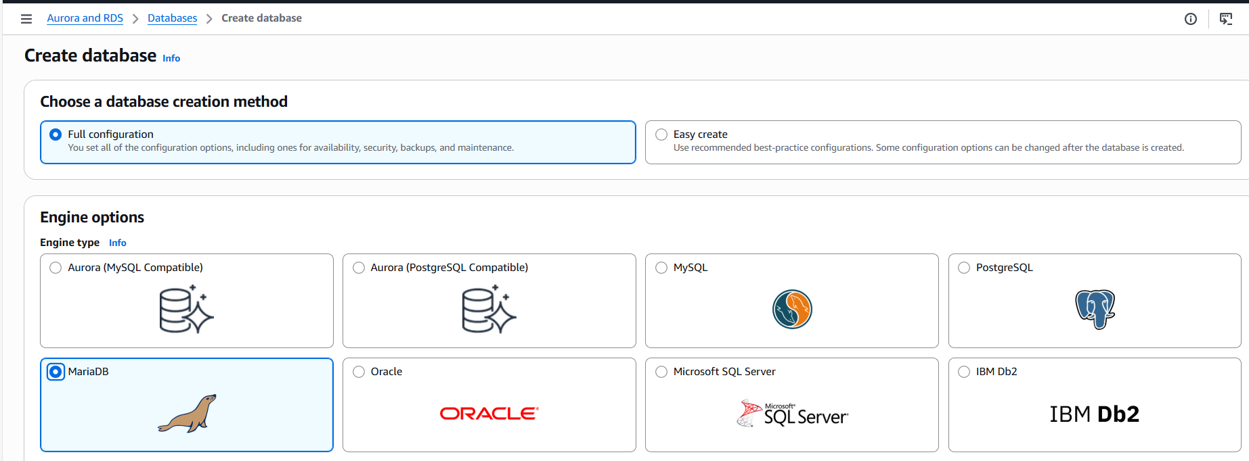

- Select the Engine Size and choose a sample template.
- Here, we selected free tier for development purposes.
- Master username is admin
- I have selected self-managed, instead of aws managed for credentials.
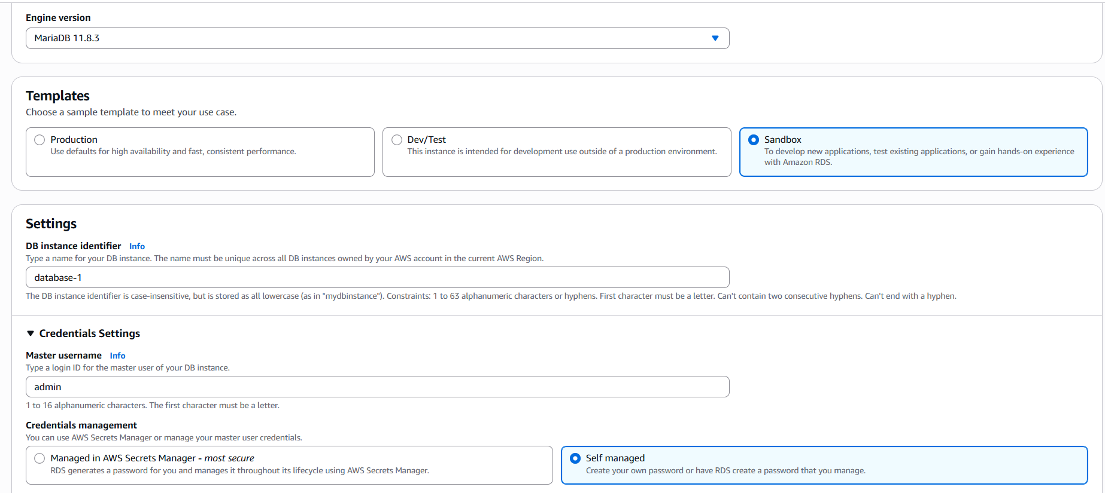

- Master password is set.
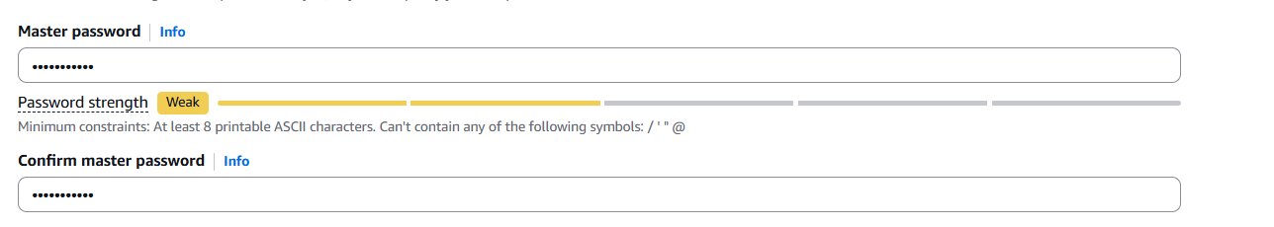

- Select the configuration- here as per the free trail- Burstable class is available.
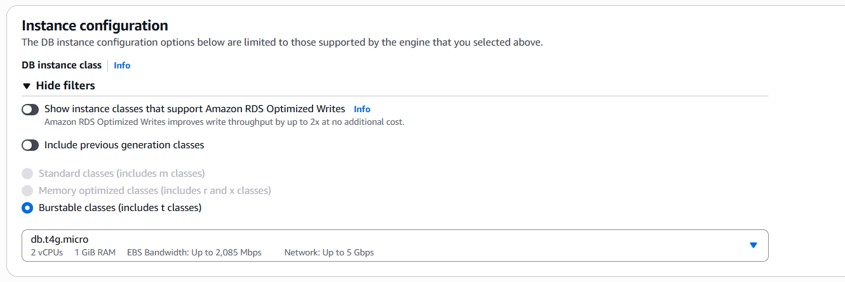

- Storage is allocated.
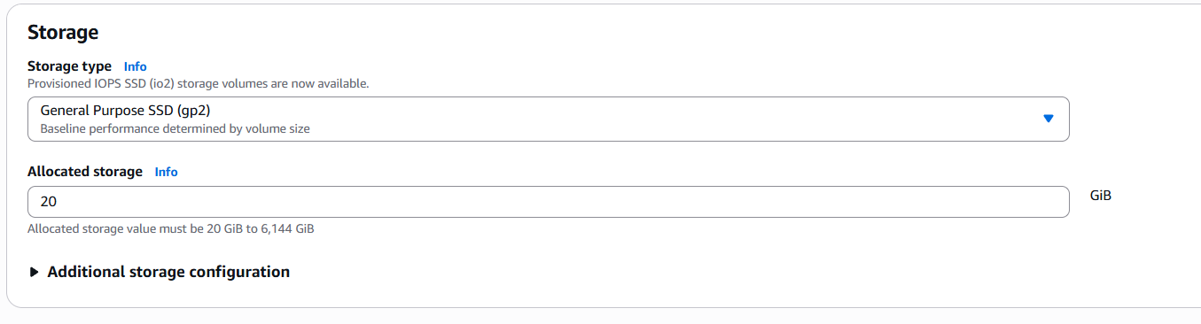
- Connectivity is updated to connect to ec2 and updated default VPC.
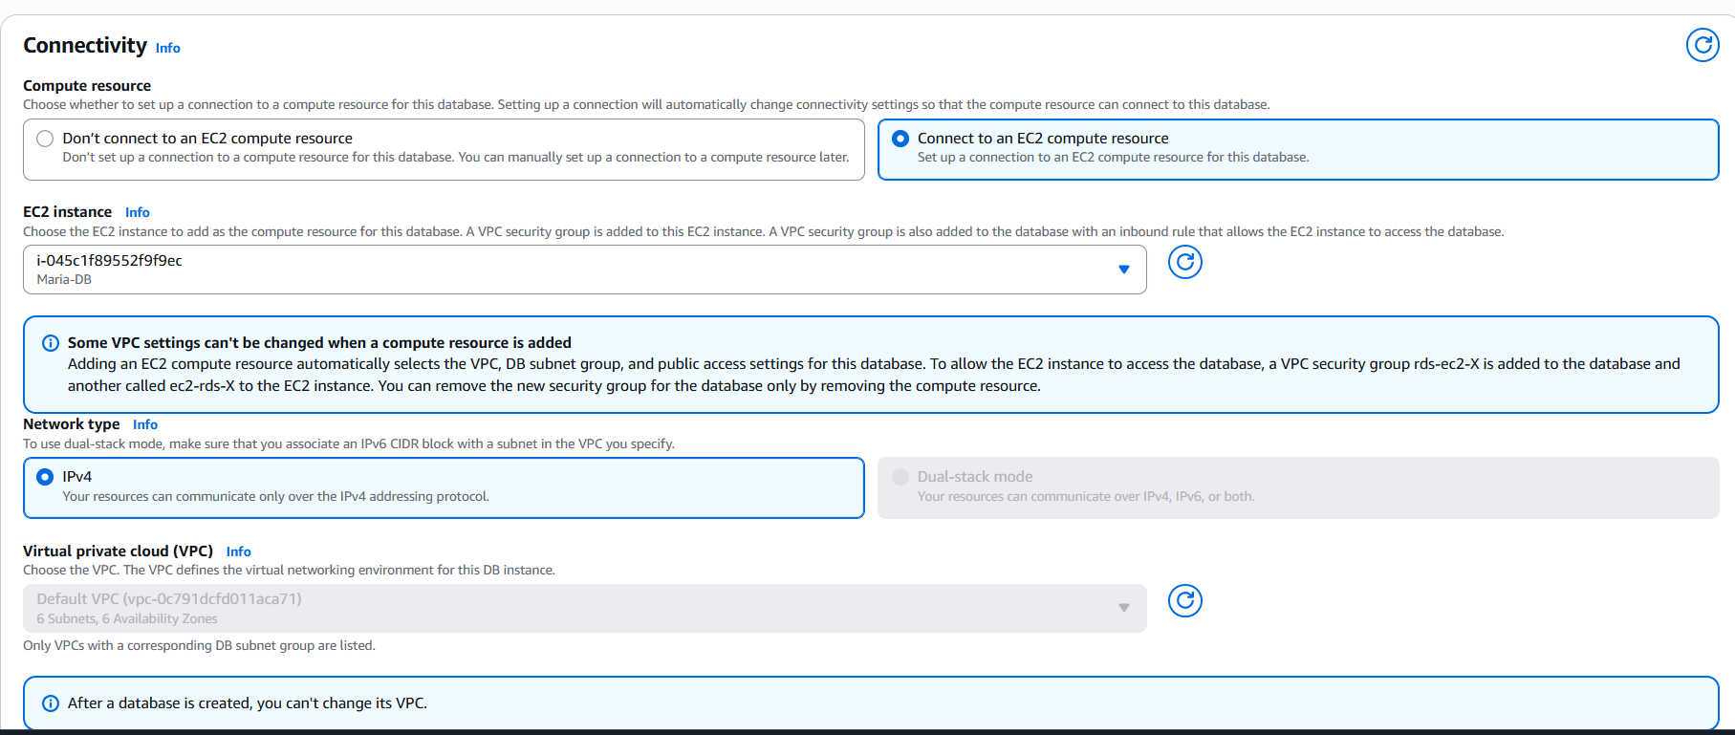

- Here, we are not selecting any monitoring services.
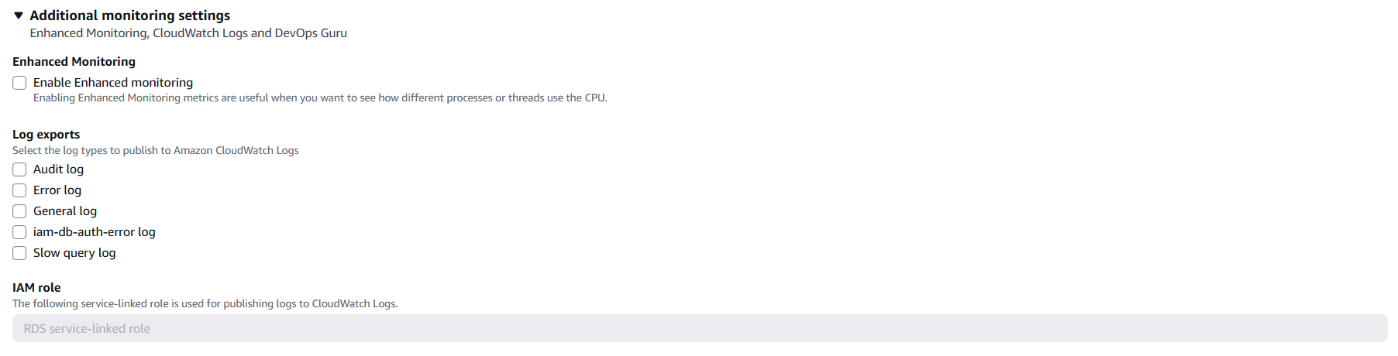
- Its taking sometime to create a RDS.
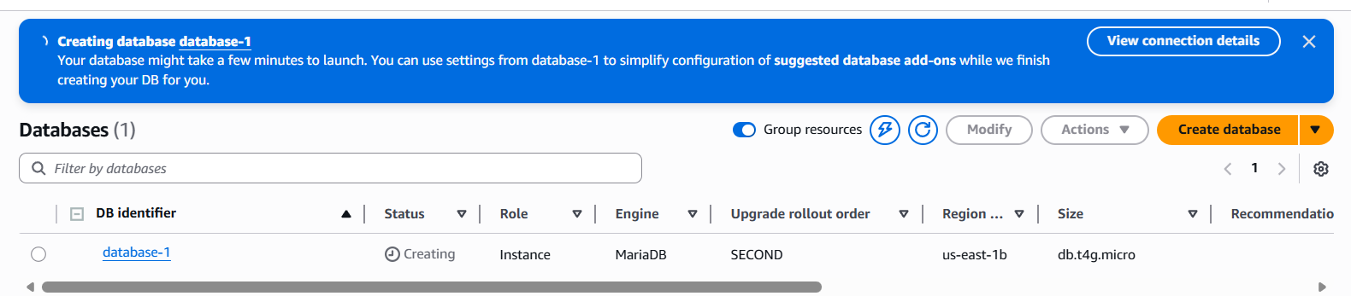
- In meanwhile, the DB is getting created, aws is asking us to save the credentials.
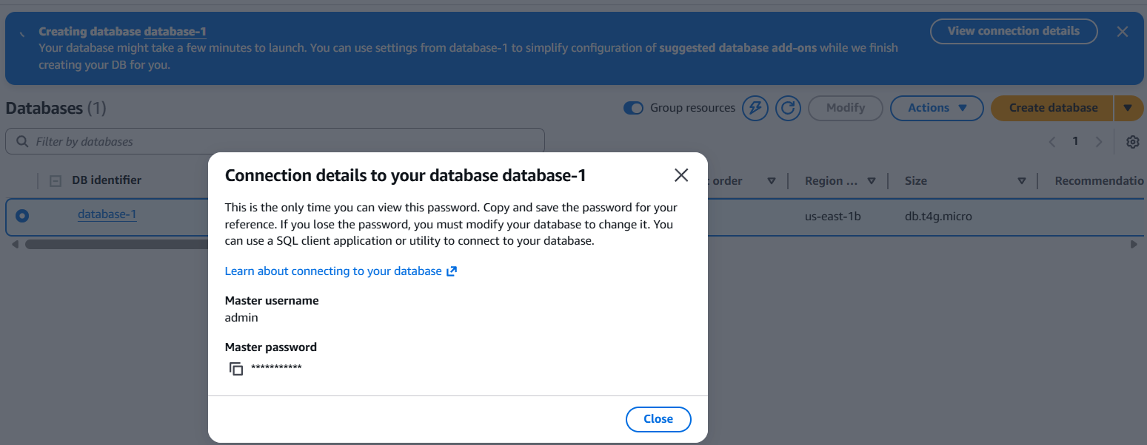
- Edit the security rules in ec2 instance to allow MySQL- 3306.
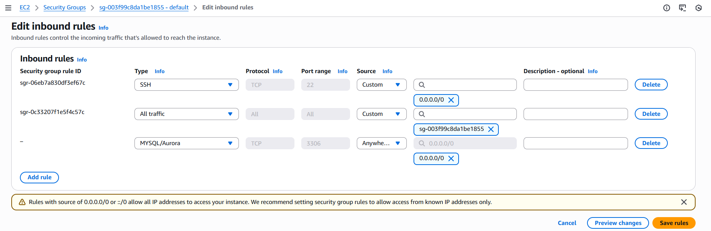

Step 2: Successfully, we created a Maria DB RDS in aws.
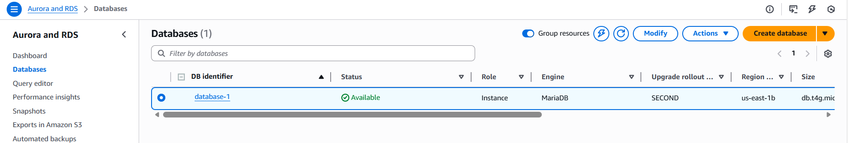

- Migrate database from EC2 to RDS.
Objective:

Migrate a database from ec2 to RDS is to improve scalability, reliability and manage operations secure.

Pre-requisites:
- Ec2
- RDS
- MariaDB
- MySQL
Step by step Implementation:
Step 1: Navigate to ec2 and click on actions Networking Connect to RDS Database.
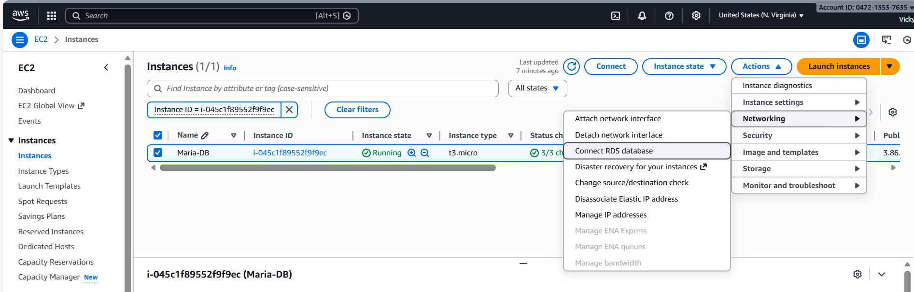

- Connect to Instance and continue
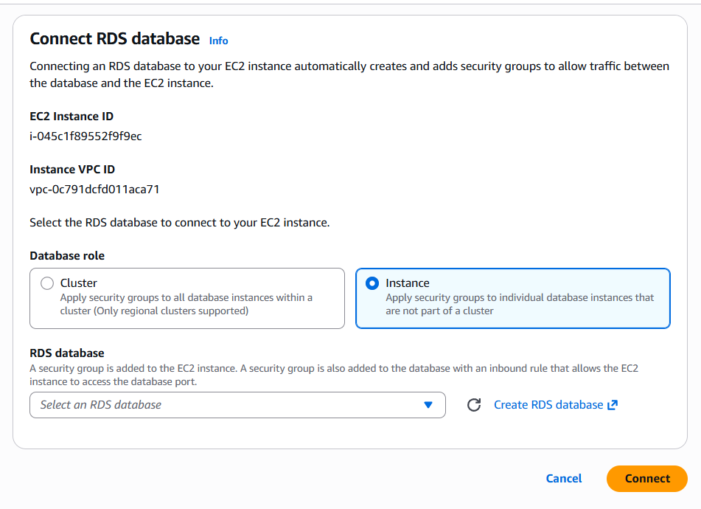
- Now we have connected to RDS database.
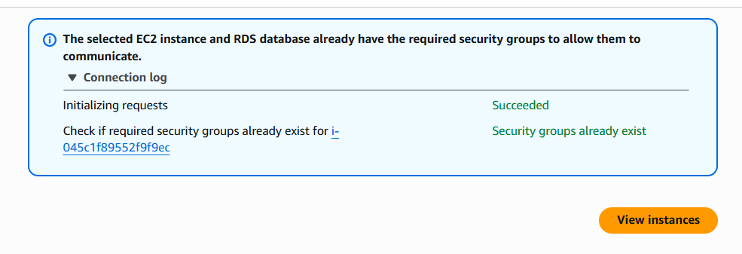
Step 2: Logged into MariaDB via ec2
- Listed Databases
- Created a new Database and verified
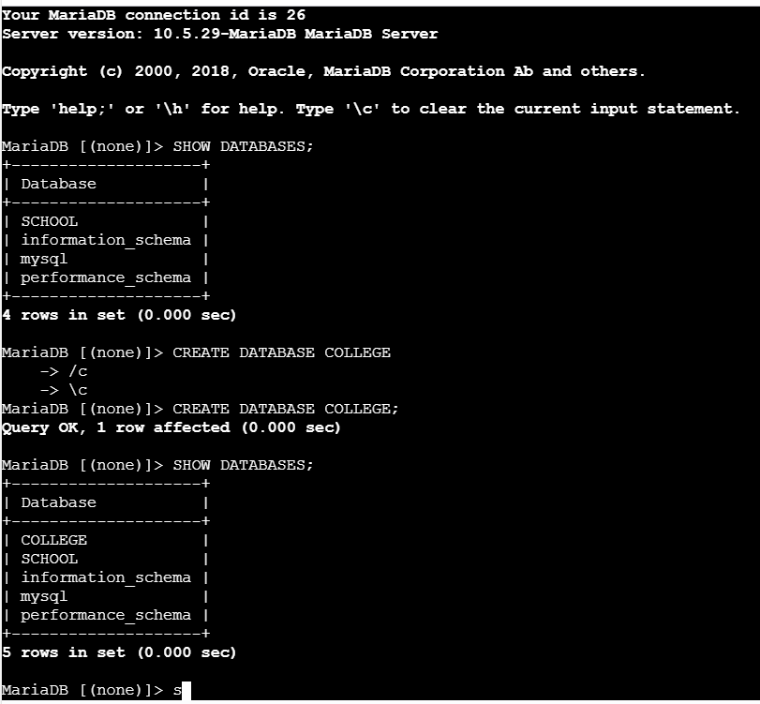

- Let’s create a table below
- Checked into College DB.
- Created Table <techie>
- Added values
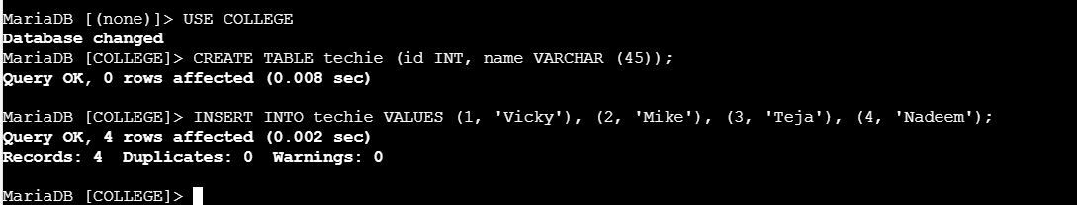

- Listed the table created.
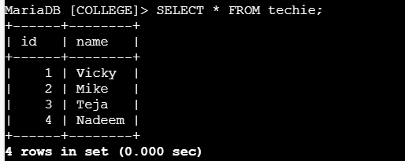
Step 3: Using command- mysqldump -u root -p <COLLEGE> >COLLEGEbackup.sql, we did backup the data.
- Using command- ls -lh, we verified the backup is successful.
- Using command- cat COLLEGEbackup.sql, we verified the tables backup is successful.
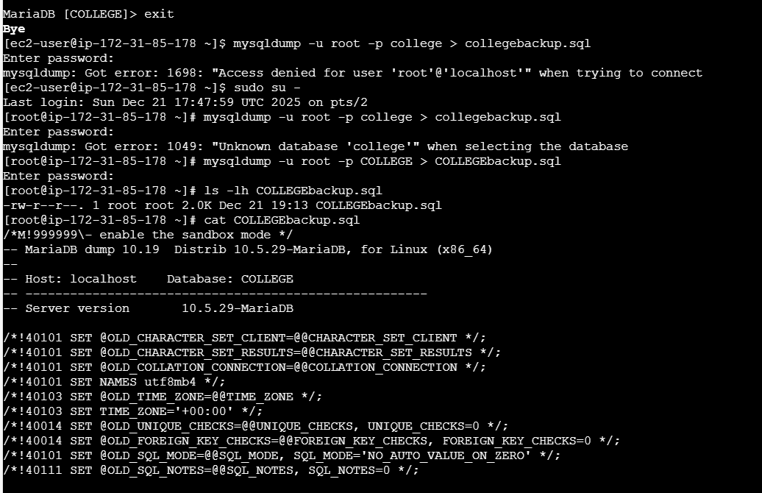

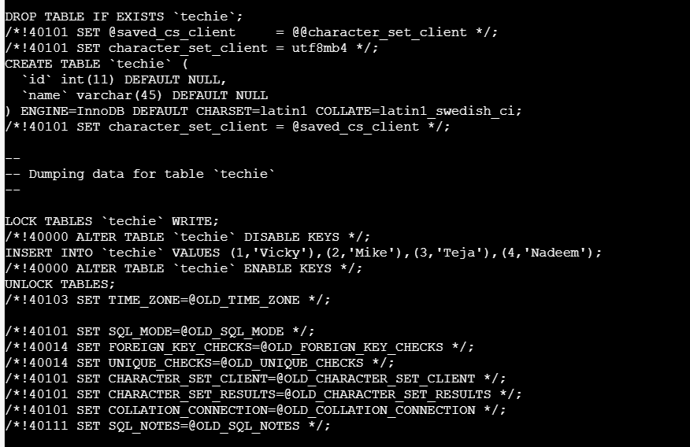
- Install MySQL DB on EC2.
Objective:

Pre-requisites:

Step by step Implementation:

- Launch MySQL RDS image.
Objective:

Pre-requisites:

Step by step Implementation:

- Configure Multi-AZ.
Objective:

Pre-requisites:

Step by step Implementation:

- Take backup of DB and restore the DB.
Objective:

Pre-requisites:

Step by step Implementation:

- Create read replica.
Objective:

Pre-requisites:

Step by step Implementation:

